**Central Nervous System**

Name: Anthony Ononiwu

Anatomy and Physiology II BIO 240 411A [28220]

Date: April 20, 2022

Professors’ Name: John Gillen

Hostos Community College

**Introduction:**

Recall from our study of nervous tissue that we divide the nervous system into two structural divisions: the central nervous system (CNS), which consists of the brain and spinal cord, and the peripheral nervous system (PNS), which consists of the cranial and spinal nerves. We address the structure and function of the CNS in this unit. The anatomy of the brain and the spinal cord may seem complex, but really it simply consists of a hollow, folded tube with an enlarged end (the brain). Together these two organs monitor and maintain many homeostatic variables, interpret sensation, plan and execute movement, and control our higher brain functions. The anatomy of both organs will be explored in the three exercises in this unit.

**Objectives**:

Often structures of the brain and spinal cord are difficult to see on anatomical models. This exercise will allow you to examine these structures more closely by dissecting a preserved sheep brain. You will note that certain structures, such as the frontal lobes of the cerebral hemispheres, are proportionally smaller in the sheep than in the human brain. Note that the process of preservation makes many structures of the brain much tougher than they would be in a fresh specimen.

1. Identify structures of the brain and describe its gross anatomy.

2. Identify structures of the spinal cord and describe its anatomical organization

**Experiment: Brain Dissection**

1. If the brain is still encased in the skull, you have your work cut out for you. The

best way to approach extracting it from the skull is to take a hammer and chisel

and gently (at least as gently as one can with a hammer and chisel) remove it piece

by piece.

2. As you remove the skull, you will note a thick membrane holding the skull in place. This is the dura mater, and it

can make removal of the skull somewhat difficult. Ideally, you would like to preserve the dura, but you may end up

cutting through it as you remove the brain.

3. Once you have removed most of the skull, gently lift out the brain. (If you're careful, you may be able to get the

brain out with the pituitary gland still attached.) You may have to loosen the remaining attachments of the dura

with your finger.

4. Once the brain is out, note the thick part of the dura covering the longitudinal fissure. If you cut through this with

scissors, you will enter the superior sagittal sinus.

5. Next remove the dura to reveal the thin membrane on top of the brain. This is the arachnoid mater.

6. Remove an area of the arachnoid mater to see the shiny inner membrane-the pia mater-directly touching the

surface of the brain. Note that the pia mater follows the convolutions of the gyri and sulci.

7. Examine the surface anatomy of both the superior and the inferior surfaces of the sheep brain.

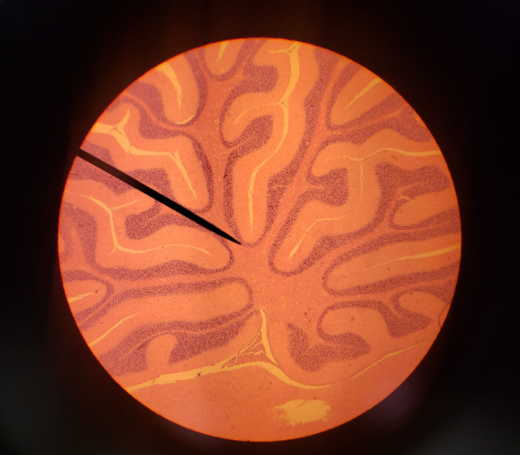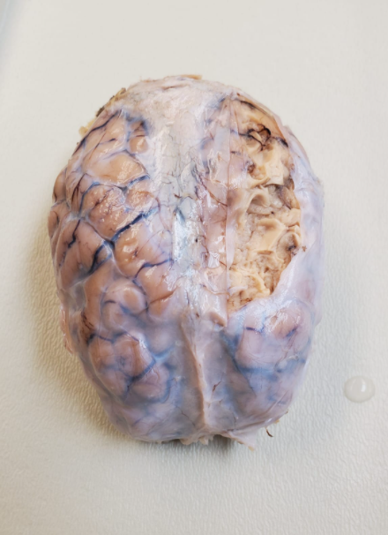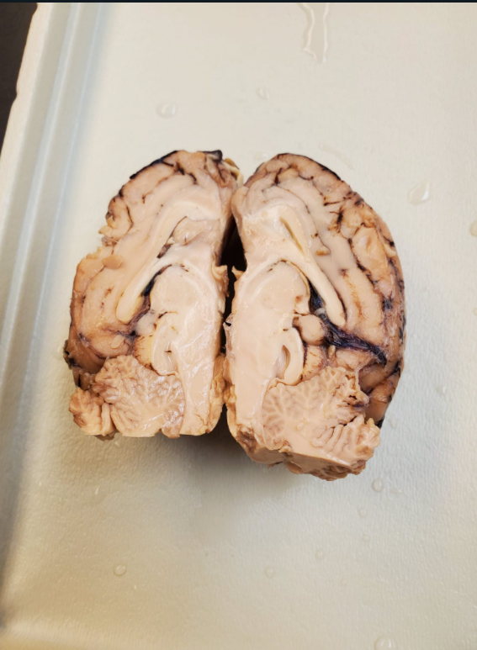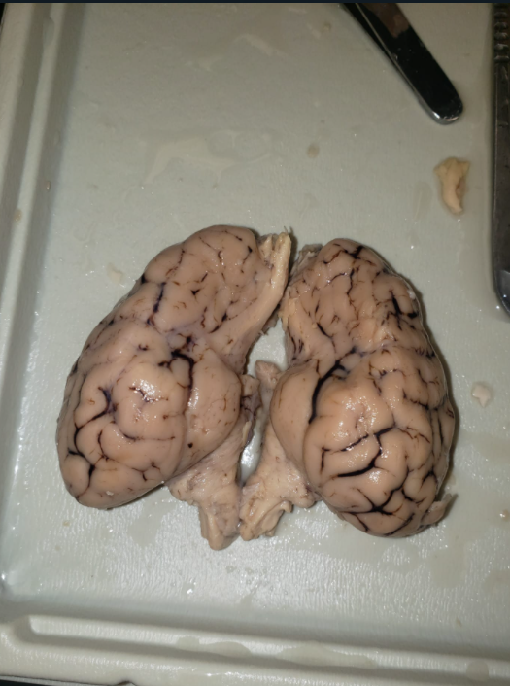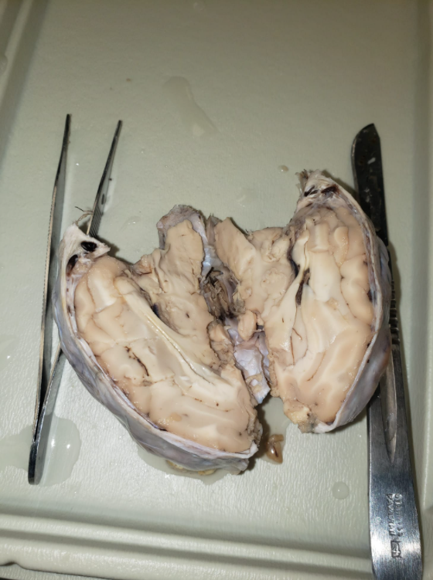

Postcentral

Gyrus

Grey

Matter

Interventricular

Foramen

Occipital

Lobe

Parietal

lobe

Frontal

Lobe

Longitudinal

Fissure

Third Ventricle

Putamen

Cerebral

Cortex

Sulci

Fornix

Gyri

Pons

Pituitary

Glands

Optic Chiasma